**ADMIN SCREENS**

The main user, who can be referred to as the manager, updates the GPM application for that country. He can access the admin screen and perform admin canter activities from there.

**People:**



**Add New Country:**

Currently, Iberia is being used. Presently in Iberia, only the portal and Spain are available.

If there is a need to start the GBM service in any other country within the Iberia region, the country needs to be added here.

This task is not performed during regular working hours and can only be done by the user.

Users can provide the country code, description, and other details, and then save the information.

This is not a regular activity but a one-time task for adding a new country.

**User Management:**

This process is part of user management, where access can be granted or provided.

Rules and accents can be created. This is part of user management.

Here, various elements such as user roles are explained.

Click the Add New Record.

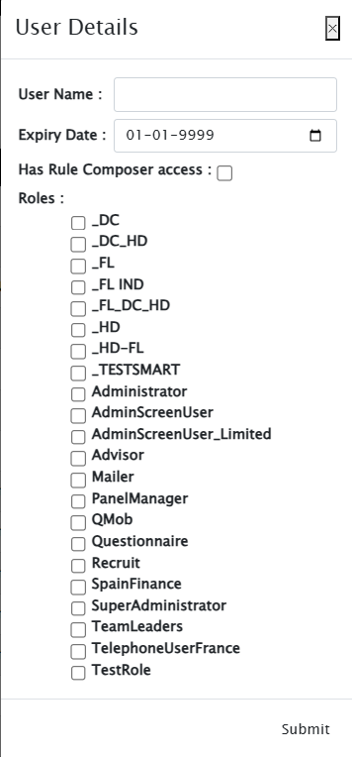

By searching for 'admin,' the system will display the admin roles assigned to users.

There are different roles, including Super Administrator, Administrator, and Admin.

The user management screen is used to manage access, grant or remove roles, and perform related activities.

In our application, Super Administrators can see everything on the GPM screen, regardless of their access level.

This is related to role management, as only roles defined in role management are visible here.

For example, a Super Administrator in GPM has default permissions to create, update, cancel, or delete options.

They can also change the panellist status directly from selector to drop out.

Other roles, such as Panel Manager or Advisor, must follow specific steps.

Super Administrator roles are typically assigned to local superusers or trusted individuals who can manage the application securely.

Sensitive data is protected by restricting certain actions to specific roles.

Super Administrator roles are not given to everyone.

Each country has Super Users who decide who should have access.

These users can see all menus and perform DML activities using the admin screen.

Initially, there was no admin screen, only the GPM main application.

Over time, user requests for data-related actions, such as deleting incorrect incentive transactions, led to the creation of the admin screen.

This screen consolidates frequent requests, allowing users to perform activities and reducing the team's workload.

This ensures critical data, like incentives, is managed correctly without affecting production activities.

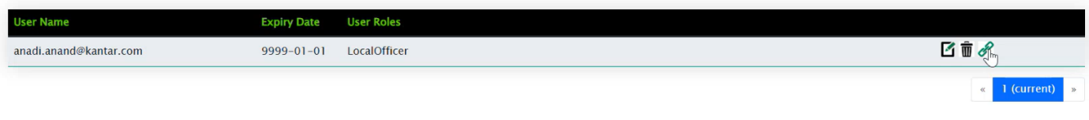

This is where the mapping is provided.

Users can choose the data they want to see based on their role, whether they are a region officer, local officer, city officer, or geographic user.

The mapping is assigned according to these roles, specifying which region or data they can access.

To add a user, click on 'Add User.' In the 'Edit User Mapping' section, if the 'Add' option is available, it will show drop-down menus for regional officer and local officer, allowing the appropriate mapping to be set

If the user is a city officer, they will be able to see the region officer, local officer, and city officer options.

If the user is a geographic user, they will be able to see all four options: region, local, city, and geographic.

The drop-down menus will populate based on the selected option, allowing the user to add mappings.

After adding the mapping, it is necessary to log out of the GPM application and log in again for the changes to take effect.

This applies to any permission changes, including granting super administrator permissions, admin screen access, or other roles.

Logging out and logging back in ensures that the new roles are applied.

**Role Management:**

Select and click 'Role Management' in the People menu bar.

The roles such as Administrator, Administrator User, Super Administrator, and Administrator Limited are displayed.

If a user needs to create a new role, the Super Admin can add the new role and assign specific permissions.



By editing the role, details can be viewed and modified.



The admin role type allows access to various areas, such as system installation and system screens.

These areas can be assigned to specific roles.



One role is designated for managing the admin screen and its roles, which is the Admin Screen User Limited role

Only then can imports be done; otherwise, the import format and files from other users will not be visible.

Click on the access area type again.

For the role type 'Admin Screen User Limited,' select the admin screen and grant or remove access as needed.

**Delete Panellist:**

Select and Click the Delete Panellist in people menu.

And add individual id in textbox and click the get panellist.

From there, provide the individual ID to delete the panel from the individual.

Navigate to the panels, and from here, select the appropriate option.

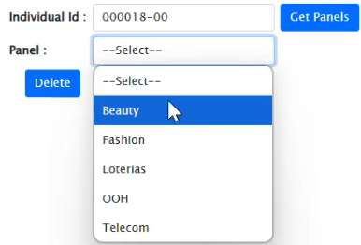

If it shows only the master panel for this individual, proceed accordingly.

Deleting a panellist does not actually delete the panel but only removes the panel from that individual.

Requests are often received to remove panels from individuals. Handling this from the back end is difficult due to the involvement of many tables.

Missing any table can affect the system. Therefore, the option to delete panellists was implemented here.

This action completely deletes the panel for that individual.

Since every action in the system is related to the panel, including communication, actions, and kits, all related data must be removed from the system.

Deleting or changing anything from the back end requires gathering all related tables and deleting the data in sequence.

Missing any data in related tables can cause issues.

When deleting a panellist, it is important to ensure that only the panel for the specific individual is removed.

If a group ID is used, only the panel for that business ID is removed, not affecting others. This process is for individual deletions.

For bulk deletions, another screen is available. Deleting records one by one is time-consuming, especially if thousands of records were created incorrectly.

The screen can be used for correcting single data entries made through the UI. For bulk records, another screen is available.

**Delete Individuals or Groups:**

Select and Click Delete Bulk Individual/Group in people menu.

I think the query should now be taken up because, during the pen test, it was advised not to provide a query directly.

Instead, a comma-separated list should be given to fetch the data.

It should show all the group individuals, right? No, it will only show the business.

Since it's a group, it will not show the individuals.

If it's an individual, it will show that individual.

**Interviewer Type:**

Select and Click Interviewer Type in people menu.

These are the interviewer types.

For Spain, interviews are not used by everyone.

In India and all MEA countries, interviews are used in markets with field workers. Interviews refer to field workers, and there are two types: interviewer and supervisor.

If the person is a supervisor, interviewers will be assigned to them.

When creating interviewers from the UI, specify whether the interviewer is a normal interviewer or a supervisor.

This type is selected from a drop-down menu in the UI while creating interviewers.

The admin screen allows the creation of reference data, including interviewer types.

**Add Dynamic Roles:**

Select and Click Add Dynamic Roles in people menu.

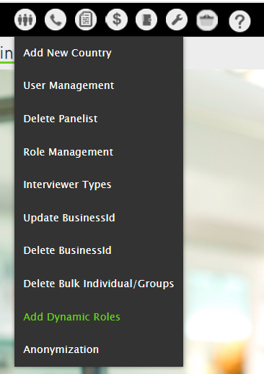

These are the dynamic roles visible on the individual screen and panel card.

Roles such as 'main shopper' depend on the panel.

The 'main shopper' role indicates that the person is the main shopper for that panel group.

The 'main contact' role, as explained by Tanuja, refers to the primary contact for the group, which could be the household owner or group owner.

The 'income updater' role is related to the person responsible for updating income information for the group.

Dynamic roles can be set here.

The main contact details are displayed here. All roles, including 'main shopper' and 'main contact,' can be viewed and edited.

Dynamic roles include panel-specific roles.

The only role that is not dynamic is the group contact role, which is why it does not appear in the dynamic roles.

All other roles are dynamic because each country has its own set of roles.

The group contact is the head of the house, homemaker, and chief. These roles are displayed in the app.

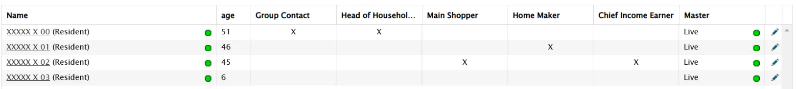

In this group, 001 is the group contact, the same for the house, and the main contact is 02, while the homemaker is 01.

These details can be viewed and edited from the household tab or by using the household import to set roles and the panellist imports to set panel-specific roles.

Most countries use imports to set roles rather than the UI, as many roles change for numerous individuals.

It is important to know which imports support this.

Household import supports group roles.

If no panel is associated, use the household import for the group. For panel roles, use the panellist imports.

The roles of individuals can be changed.

Not all individuals can be selected.

Only active individuals, such as residents or semi-residents, can be chosen.

Non-residents or deceased individuals will not appear in the drop-down menu.

If these individuals are used in an import, a business validation message will be displayed, preventing the action.

Whenever a non-resident's group membership status is changed, their role will also be removed.

**Anonymization:**

Select and Click Anonymization in people menu.

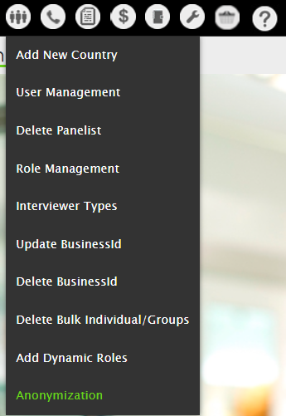

Anonymization is important for users who have been inactive for many days.

If a user requests that their PID information be removed from the system, the system will perform anonymization.

This is not done on the current screen but on a separate screen in GPM.

Anonymization can be done for a group or an individual.

If done for a group, all individuals in that group will be anonymized.

If done for an individual, only that individual will be anonymized.

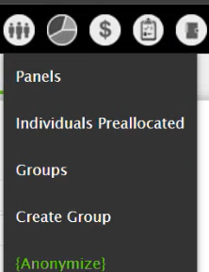

To anonymize, go to the first tab and upload a file containing the group IDs or individual IDs to be anonymized.

Sensitive demographic information and address details will be anonymized automatically.

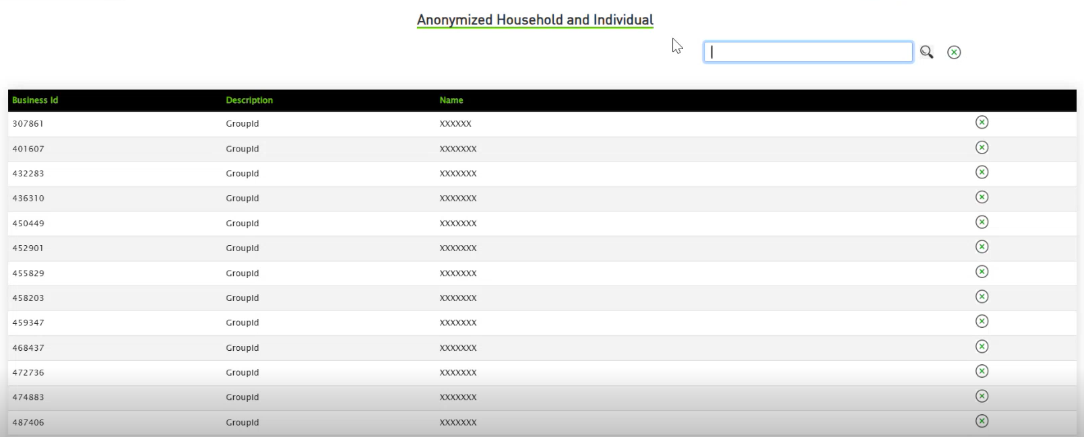

The screen is necessary because if a user mistakenly anonymizes data and wants to revert it, they can do so within seven days.

This configuration is based on the country, with a default of seven days. During this period, the group ID can be seen and clicking 'Cancel' will revert the anonymized information to its original value.

During the anonymization process, audit table records are also deleted to prevent retrieving the information later.

This ensures no option to retry the information once anonymization is complete.

A cooling period is provided for users to revert any mistakes within the allowed timeframe.

Even if a user is permanently deleted from the system, there should ideally be some trace of the individual with Kantar.

However, the individual is not completely deleted; they remain part of Kantar, and their information is still there, except for their PID information, which is removed during anonymization.

The panellist is not deleted from GPM, only their PID information is removed. The panellist can still be seen in GPM.

**Email or SMS Linking:**

Select and Click Email or SMS Linking in Communication menu.

